**Project Design Phase-II**

**Data Flow Diagram & User Stories**

|  |  |
| --- | --- |
| Date | 03 October 2022 |
| Team ID | PNT2022TMID37477 |
| Project Name | Smart Fashion Recommender Application |
| Maximum Marks | 4 Marks |

***Data Flow Diagrams*:**

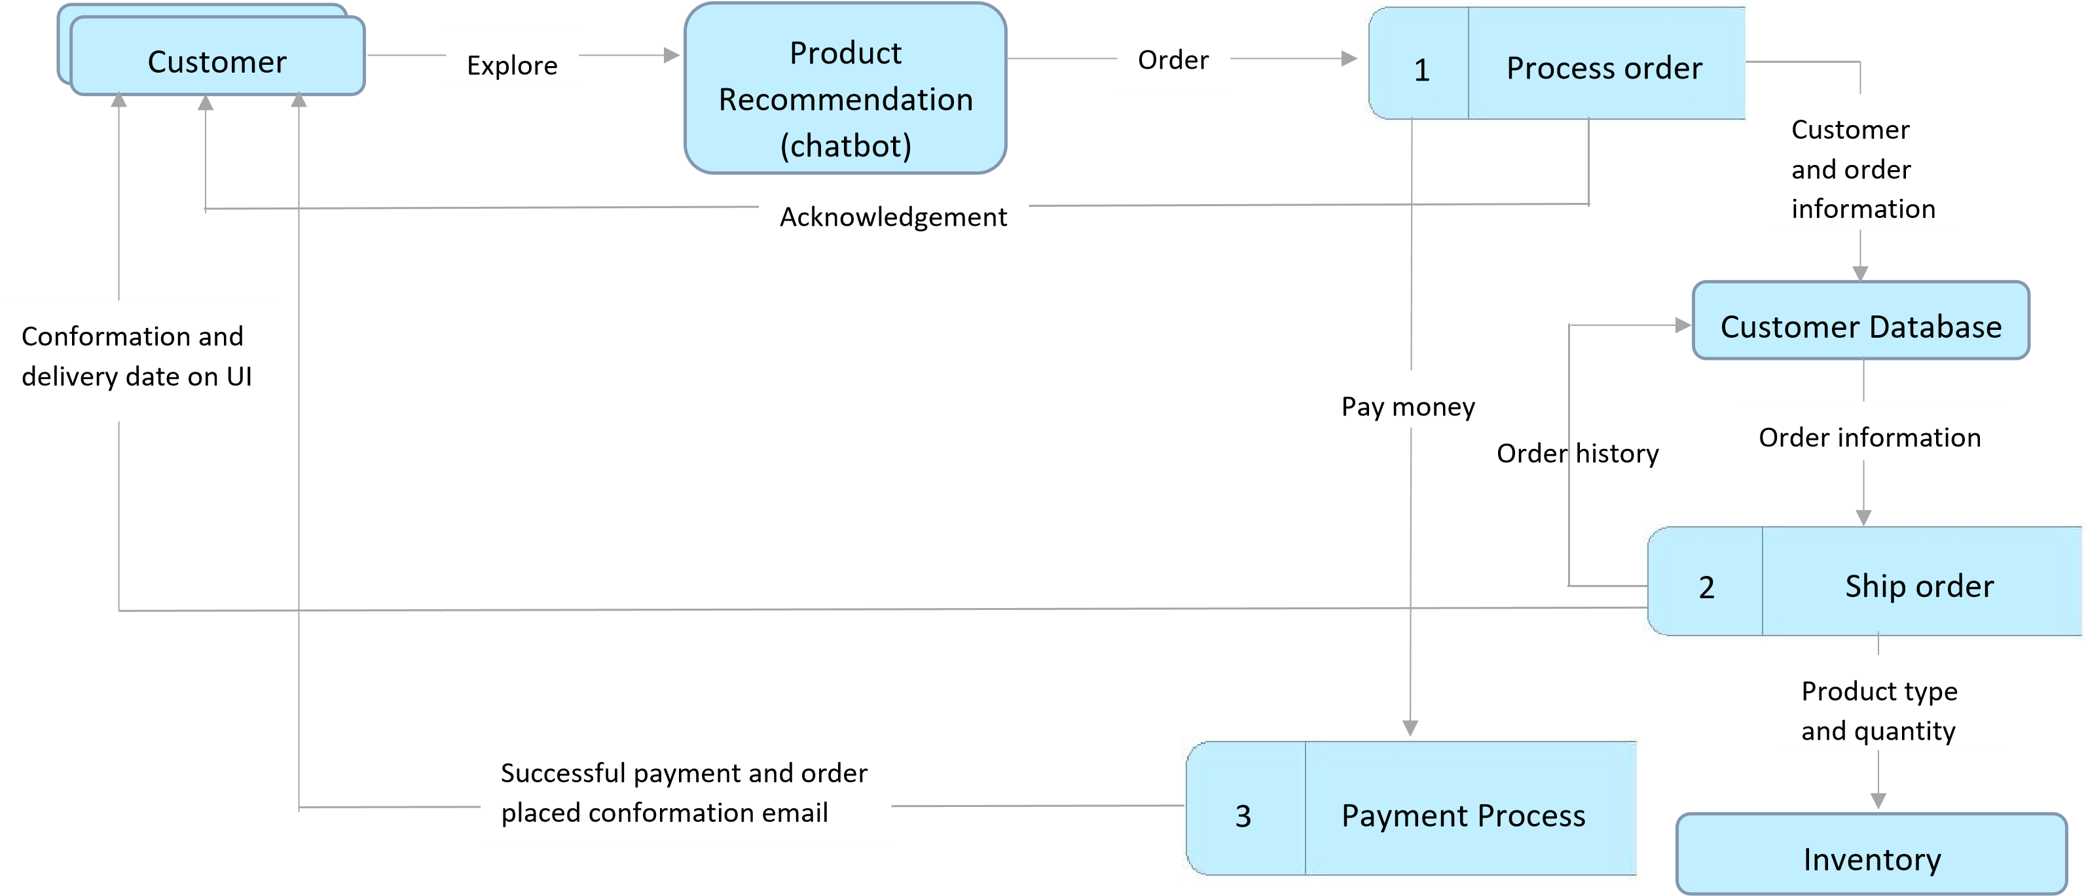

**User Stories**

Use the below template to list all the user stories for the product.

|  |  |  |  |  |  |  |
| --- | --- | --- | --- | --- | --- | --- |
| **User Type** | **Functional**  **Requirement**  **(Epic)** | **User Story Number** | **User Story / Task** | **Acceptance criteria** | **Priority** | **Release** |
| Customer (Web  user) | Registration | USN-1 | As a user, I can register for the application by entering my email, password, and confirming my password. | I can access my account or redirected to the next process. | High | Sprint-1 |
|  |  | USN-2 | As a user, I will receive confirmation email once I have registered for the application | I can receive confirmation email & click confirm | High | Sprint-1 |
|  | Login | USN-3 | As a user, I can log into the application by entering email & password | I can be redirected to the dashboard. | High | Sprint-1 |
|  | Dashboard | USN-4 | As a user, I can explore the products on the site. | I can ask recommendations from the chatbot. | High | Sprint-1 |
|  |  |  |  | I can view the offers and deals. |  |  |
|  | Chatbot | USN-5 | As a user, I can find my desired products through recommendation. | I can save my time in exploring the products. | High | Sprint-2 |
|  | Wishlist | USN-6 | As a user, I can add the products to my wish list. | I can save products for future reference. | Medium | Sprint-2 |
|  | Payment | USN-7 | As a user, I can make payment. | I will receive mail after successful payment. | High | Sprint-3 |
|  | Order  Confirmation | USN-8 | As a user, I will receive a confirmation email. | I can be assured of secured payment. | High | Sprint-3 |
|  | Coupon  Generation | USN-9 | As a user, I will be provided with customised coupons on my birthday. | I will be contented and saving money on my special day. | Low | Sprint-4 |
|  | Shipping | USN-10 | As a user, I will be able to view the estimated time of delivery. | I can track my orders. | Medium | Sprint-4 |
| Administrator | Login | USN-11 | As an admin, I can register for the application  by entering my email, password, and confirming my password. | I can track users’ purchases. | High | Sprint-4 |

|  |  |  |  |  |  |  |
| --- | --- | --- | --- | --- | --- | --- |
|  |  |  |  | I can check the database of the stock. |  |  |